**Topic: Maps, building plans, scale drawings**

Time: 45 mins Marks: /45 marks

**Calculator Assumed**



**Question One: [3, 2, 2, 2: 9 marks]**

a) Paulie is building a go-cart and is following instructions and plans which include a scale drawing of the go-cart. The drawing uses a scale of 1 : 25. If the seat of the go-cart is a rectangle which measures 5 cm by 7 cm in the drawing, what is the area of the actual seat?

b) Adriana made a scale drawing of her hair salon. She used the scale 2 centimetres = 1 metre. If her salon door is half a metre wide how long will this be in the drawing?

c) Christopher made a scale drawing of his farm. He used the scale 13 millimetres = 7 metres. In the drawing the pig pen is 9 mm long. How long is the actual pig pen (correct to 2 decimal places).

d) Nick’s bedroom is rectangular and measures 3 m by 4 m. Is it possible for him to use an entire piece of A4 paper, measuring 210 mm by 297 mm to represent the floor plan of his room?

**Question Two: [3, 2, 4: 9 marks]**

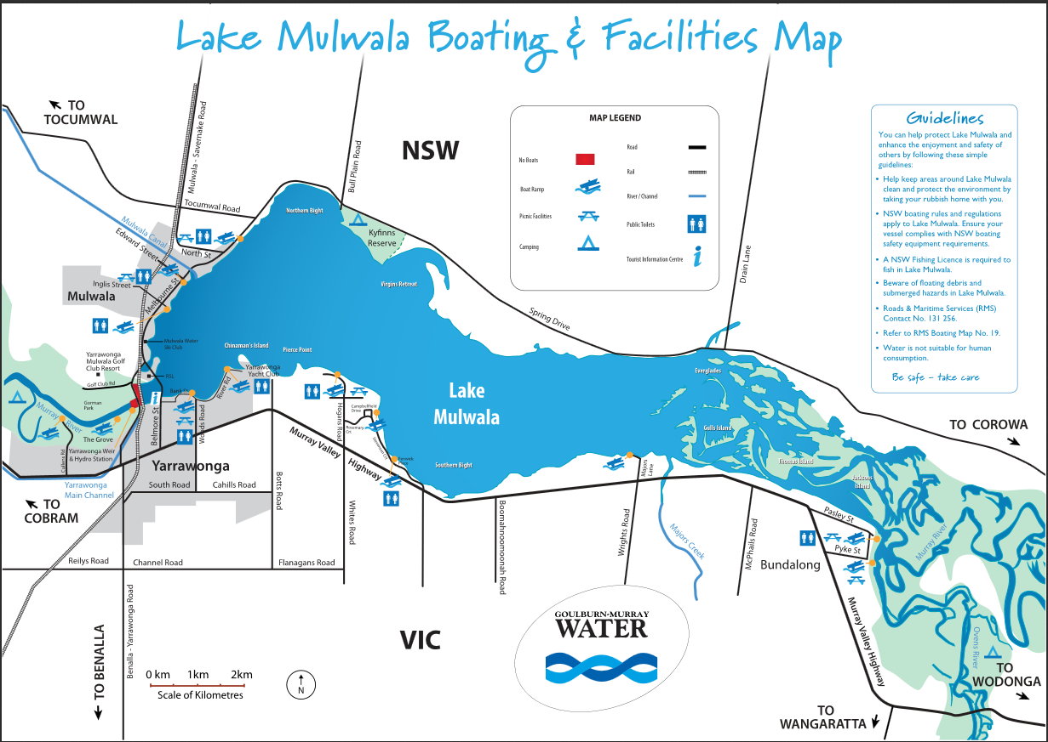Consider the following map of Lake Mulwala in NSW.

Source: <http://www.lakemulwala.org.au/>

Use the map of Lake Mulwala on the previous page to answer the following questions.

a) Approximately how many kilometres long is Channel Road?

b) Silvio launches a boat into the lake at the boat ramp on Edward Street (next to Mulwala Canal).

i) If he sails the boat in a straight line, all the way to boat launch on Majors Lane (end of Wrights road), how many kilometres has he travelled? (From to )

ii) If Silvio sails the boat at 47 km/hr to Majors Lane, stops for 30 mins at Majors Lane and then sails back along the same straight line and at the same speed, how long will his whole journey take?

**Question Three: [3, 4: 7 marks]**

Use the following maps to answer the questions on the next page.

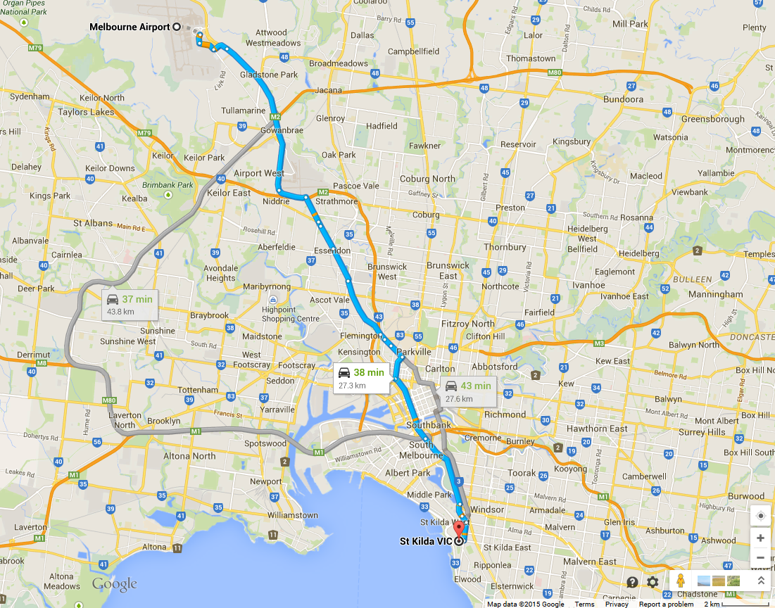

**Route 1**

**Route 3**

**Route 2**

1 cm on the map is 2 km

Janice has just arrived at Melbourne Airport and she wants to visit her Uncle Junior who is living in St. Kilda.

She has hired a car and is trying to find the best route to St. Kilda so she is looking on Google maps. Google maps has provided her with three alternate routes to get from the airport to St. Kilda. Route 3 is 27.6 km long and will take 43 mins.

a) Calculate the approximate distance of Route 1 (in km).

b) Assuming she travels at the same speed if she takes route 1 or 2 as she would if she chose route 3, calculate how long the journey would take with route 1 and route 2.

**Question Four: [9, 2: 11 marks]**

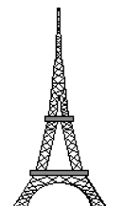



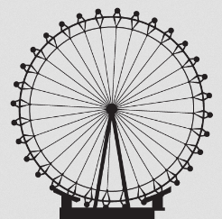

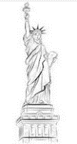

Great Pyramid London Eye Effel Tower Statue of Centre Point of Giza Liberty Tower Sydney

Jennifer is comparing the heights of different monuments and has created the scale drawing above. The actual height of the Eiffel Tower is 301 m.

a) Calculate the heights of the other monuments to the nearest metre.

b) The real height of Big Ben is 96 m, to what height on the above scale would it be drawn?

**Question Five: [4, 2, 3: 9 marks]**

a) Increase the following image by a scale factor of 3 and calculate the perimeter of the shaded face to the nearest metre on the enlarged image.



b) The following hemisphere has a volume of 150 cm3.

i) Reduce the size of the sphere by a scale factor of 3 and calculate the volume of the smaller sphere.

ii) Calculate the radius of the larger hemisphere.

**Maps, building plans, scale drawings SOLUTIONS**

Time: 45 mins Marks: /45 marks

**Calculator Assumed**



**Question One: [3, 2, 2, 2: 9 marks]**

a) Paulie is building a go-cart and is following instructions and plans which include a scale drawing of the go-cart. The drawing uses a scale of 1 : 25. If the seat of the go-cart is a rectangle which measures 5 cm by 7 cm in the drawing, what is the area of the actual seat?

b) Adriana made a scale drawing of her hair salon. She used the scale 2 centimetres = 1 metre. If her salon door is half a metre wide how long will this be in the drawing?



c) Christopher made a scale drawing of his farm. He used the scale 13 millimetres = 7 metres. In the drawing the pig pen is 9 mm long. How long is the actual pig pen (correct to 2 decimal places).



d) Nick’s bedroom is rectangular and measures 3 m by 4 m. Is it possible for him to use an entire piece of A4 paper, measuring 210 mm by 297 mm to represent the floor plan of his room?

**Question Two: [3, 2, 4: 9 marks]**

Consider the following map of Lake Mulwala in NSW.

Source: <http://www.lakemulwala.org.au/>

Use the map of Lake Mulwala on the previous page to answer the following questions.

a) Approximately how many kilometres long is Channel Road?

b) Silvio launches a boat into the lake at the boat ramp on Edward Street (next to Mulwala Canal).

i) If he sails the boat in a straight line, all the way to boat launch on Majors Lane (end of Wrights road), how many kilometres has he travelled? (From to )

ii) If Silvio sails the boat at 47 km/hr to Majors Lane, stops for 30 mins at Majors Lane and then sails back along the same straight line and at the same speed, how long will his whole journey take?



**Question Three: [3, 4: 7 marks]**

Use the following maps to answer the questions on the next page.



**Route 1**

**Route 3**

**Route 2**

1 cm on the map is 2 km

Janice has just arrived at Melbourne Airport and she wants to visit her Uncle Junior who is living in St. Kilda.

She has hired a car and is trying to find the best route to St. Kilda so she is looking on Google maps. Google maps has provided her with three alternate routes to get from the airport to St. Kilda. Route 3 is 27.6 km long and will take 43 mins.

a) Calculate the approximate distance of Route 1 (in km).



b) Assuming she travels at the same speed if she takes route 1 or 2 as she would if she chose route 3, calculate how long the journey would take with route 1 and route 2.





**Question Four: [9, 2: 11 marks]**









Great Pyramid London Eye Effel Tower Statue of Centre Point of Giza Liberty Tower Sydney

Jennifer is comparing the heights of different monuments and has created the scale drawing above. The actual height of the Eiffel Tower is 301 m.

a) Calculate the heights of the other monuments to the nearest metre.

Pyramid = 137 m

London Eye = 128 m

Statue of Liberty = 100 m

Centre Point = 319 m

b) The real height of Big Ben is 96 m, to what height on the above scale would it be drawn?



**Question Five: [4, 2, 3: 9 marks]**

a) Increase the following image by a scale factor of 3 and calculate the perimeter of the shaded face to the nearest metre on the enlarged image.







b) The following hemisphere has a volume of 150 cm3.

i) Reduce the size of the sphere by a scale factor of 3 and calculate the volume of the smaller sphere.

ii) Calculate the radius of the larger hemisphere.

